CO10029 - Fundamentals of Programming
Name: Sovithyea Prach
Student ID: 105270743
Task 2.1
Code:
#include <iostream>
#include <string>
using namespace std;

int main()
{
string name;
int mark1, mark2;
int total_mark;
float average;
string grade;

//asking for students name
cout<<"Enter name of the student: ";
cin>>name;

//asking for mark 1 and 2
cout<<"Please enter student's mark1: ";
cin>>mark1;
cout<<"Please enter student's mark2: ";
cin>>mark2;

//asking for students grade
cout<<"What is the grade? ";
cin>>grade;

//finding average
total_mark = mark1 + mark2;
average = total_mark/2.0;

//output
cout<< "The student " <<name<< " has an average score of " <<average<< " and got a " <<grade<< " grade " <<endl;

return 0;
}

Output window:
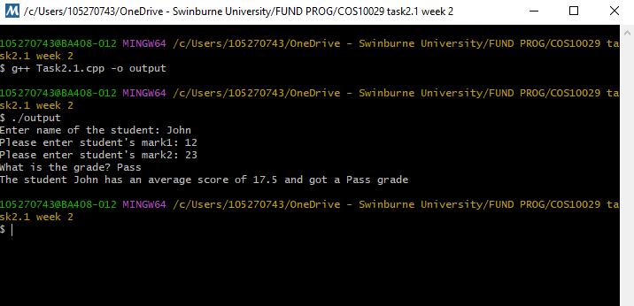

Task 2.2
Code:
#include "splashkit.h"
using namespace std;

int main()
{
open_window("Splashkit Drawing", 800, 800);
clear_screen(COLOR_BLUE);
fill_ellipse(COLOR_GREEN,0,600,800,600);
fill_rectangle(COLOR_RED, 400,400,200,200);
fill_rectangle(COLOR_YELLOW, 200,200,200,200);
refresh_screen();
delay (5000);
return 0;
}

Output window:
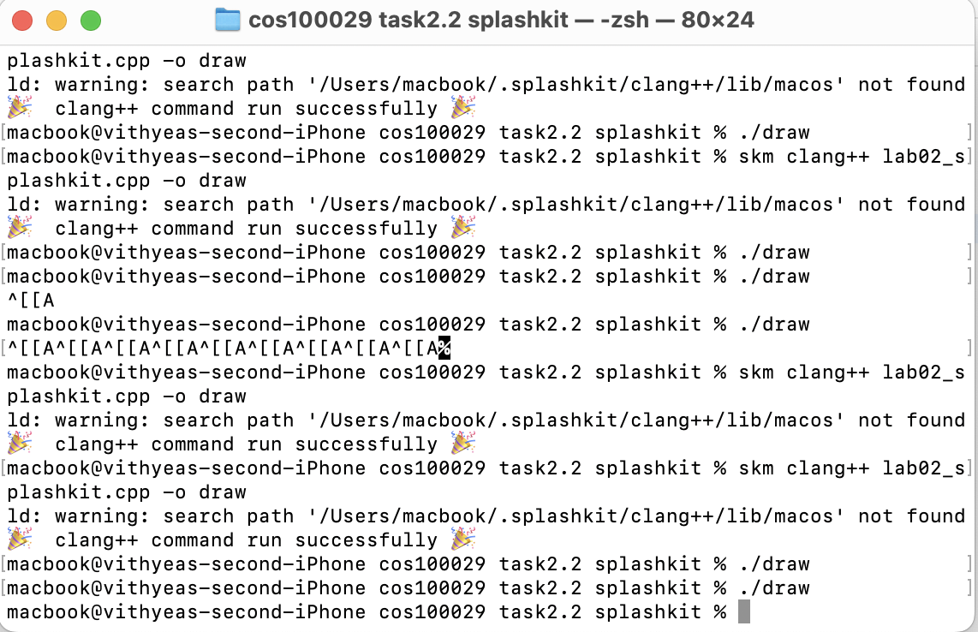
Splashkit:
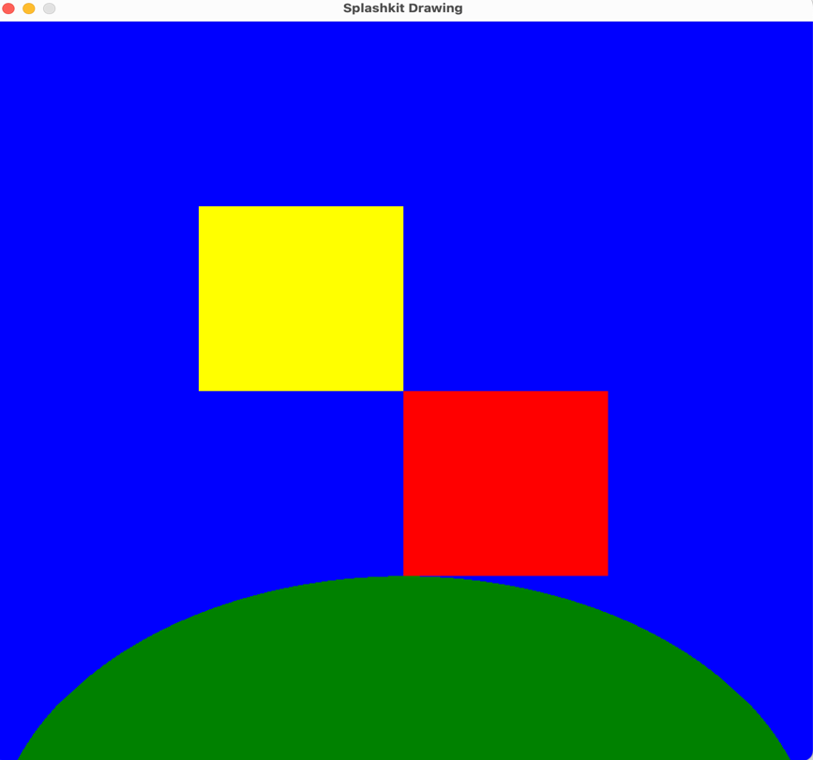
Task 2.3
Code:
//bus drawing
#include "splashkit.h"
using namespace std;

void draw_green_bus()
{
fill_rectangle(COLOR_GREEN, 200,100,100,50);
fill_circle(COLOR_BLACK, 225,150,10);
fill_circle(COLOR_BLACK, 275,150,10);
}

void draw_red_bus()
{
fill_rectangle(COLOR_RED, 200,100,100,50);
fill_circle(COLOR_BLACK, 225,150,10);
fill_circle(COLOR_BLACK, 275,150,10);
}

int main()
{
open_window("Bus Drawing", 800,600);
clear_screen(COLOR_WHITE);
draw_green_bus();
refresh_screen();
delay(5000);

clear_screen(COLOR_WHITE);
draw_red_bus();
refresh_screen();
delay(5000);

return 0;
}

Output window:
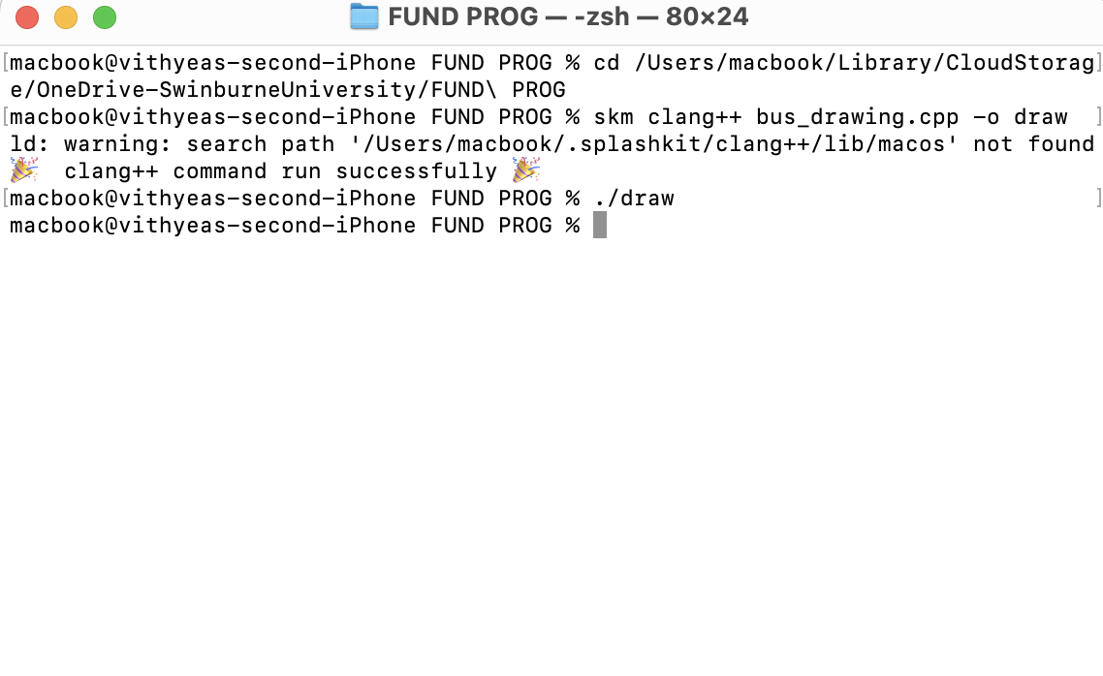
Bus drawing:
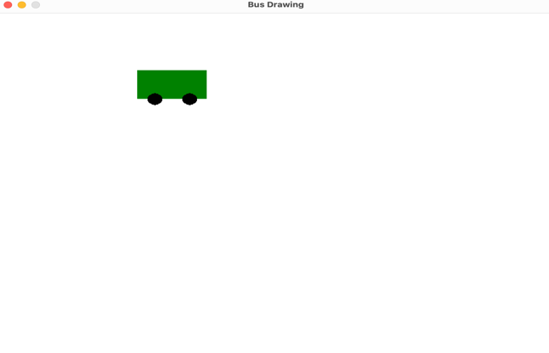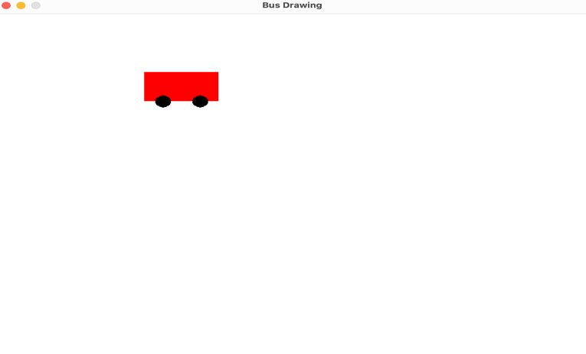
Task 2.4
Program 1
int a, b, c;
a=10;
b=20;
c=a+b;
cout<<“ c= ”<<c<<endl;
10
a
20
b
c
30

Output:
c= 30
Program 2
int num1, num_2;
num1=20;
num_2=30;
cout<<num1<<num_2-10<<endl;
20
num1
30
num2
Output:
2020
Program 3
int var_1,var_2,var_3,var_4,var_5;
var_1=100;
var_2=200;
var_3=var_2+var_1;
var_4=300;
var_5=var_2+var_4;
var_4=var_5;
var_2=var_3;
cout<<var_1<<“\n”<<var_2<<endl;
cout<<var_3<<var_4;
cout<<var_5;
100
var_1
200 300
var_2
300
var_3
300 500
var_4
500
var_5
Output:
100
200
300500500
Float
Integer
Integer
Integer
String
String
Float
Float

Integer
